Communication for Health Care Professionals 1
NCSI1182A
Module 1 Basic Communication
Krystal Pitre/ Betty Lydon June 2023
Think About It!
“Communication is the key to safe health care. When health care workers communicate effectively, fewer errors occur, and people are more satisfied. The majority of errors in health care are linked to a lack of proper communication. …Since patient safety is the first priority in nursing care, effective communication should be incorporated in all of the components of planning so that nurses can provide the highest quality of care” (Arnold and Boggs, pg 18).
In This Module:
Goal: To gain knowledge on the types of communication and the differences between each.
Competencies:
Identify types of communication
  - verbal, nonverbal and written
  - congruence between verbal and nonverbal
  - body language and proxemics
  - difference between social and therapeutic
Readings: Arnold and Boggs’s Interpersonal Relationships; Professional Skills for Canadian Nurses.

Defining communication

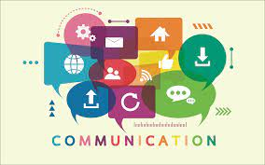
Reference

What is Communication?

“Communication refers to each transmission of information, whether intentional or not. Nonverbal behaviours, written communication, tone of voice, and words are all forms of communication. The concept takes into consideration the values and beliefs, words and ideas, emotions, and body language of the sender, receiver, and context” (Arnold and Boggs, pg 72).
"Communication Takes EFFORT it is a complex, ongoing process that brings us into contact with the people in our world. Communication can be viewed as a straightforward exchange of messages between a speaker and a listener. However, a key to interpreting communication is finding the meanings of messages, which are found in people, not words." (Gavin and Wilkinson, 2006).
Communication is the process of sharing our ideas, thoughts, and feelings with other people and having those ideas, thoughts, and feelings understood by the people we are talking with. When we communicate, we speak, listen, and observe. Effective communication at work, home, and in life is probably one of the most important skills a person needs.
Communication occurs when one person sends a message to another person who receives it, processes it, and indicates that the message has been interpreted. The receiver must acknowledge that the message has been received and comprehended for the communication to be complete.
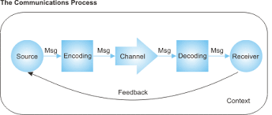
Reference
Communication is a two-way process.
This process works as follows:
- The messenger has something to communicate, a message. This message has intent.
- The messenger will encode his message with words, behavior, and body language that the senses will help him to best communicate this message according to his intent.
- The message will go through a channel, a means of communication such as e-mail, face-to-face or phone conversation, letter, or presentation.
- The receiver will then decode the message using conventions, cultural or contextual background, and language skills.
- The message he receives might or might not meet the intent of the messenger and therefore provides feedback to the sender.

Verbal, written and non verbal communication:

“Communication is a combination of verbal and nonverbal behaviours integrated for the purpose of sharing information … Communication style is defined as a set of specific, speech-related characteristics, cueing others as to how to interpret a message …..Verbal style includes the actual words spoken. Nonverbal style includes pitch (high or low), tone, facial expression, gestures, body posture and movement, eye contact, distance from the other person, and so on (Arnold and Boggs, pg 95).
Verbal Communication: the use words/language in written or spoken form.
- Oral Communication: Oral communication is information spoken by mouth; the use of speech.
- Written Communication: Communication by means of written symbols (either printed or handwritten)
Non-verbal communication: includes a whole series of physical gestures such as facial expressions, signals, and general gestures, body movements, use of colors, eye contact, and the use of tone and sounds. It is important to recognize the significance of non-verbal communication in normal interpersonal communication.
- “Most of our person-to-person communication is nonverbal. All our words are accompanied by nonverbal cues that offer meaning about how to interpret the message… The function of nonverbal communication is to give us cues about what is being communicated. We give meaning about the purpose or context of our message nonverbally; this can increase the accuracy and efficiency of its impact on the listener” (Arnold and Boggs Pg. 95).

Body Language and proxemics

Some common non-verbal communication (United nations 2003- Conflict-2 (creducation.net))
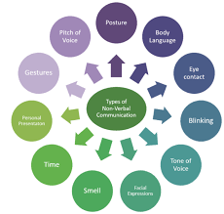
Reference

- Physical appearance: tells us something about the speaker’s attitude towards herself/himself. Though you may hate to admit it, all of us make certain assumptions about people based on the way they dress. However, our assumptions are not always correct.

- Gestures and facial expressions: are direct clues to the speakers’ immediate thoughts.

  - Facial expressions are difficult to control and express the speaker’s thoughts. The face is one of the most noticed parts of your body. You read a lot about a person by their facial expression. As you read each of the following words you can likely think of a facial expression to match the word: happiness, sadness, fear, anger, surprise, disgust. As with all non-verbal communication, facial expressions can also be misread. The way a person uses her/his hands also shows feelings.
  - Gestures are important clues in cases when the speaker is unfamiliar with the language of the listener. Some gestures involve movement of the hands and arms: these are commonly used when you are describing something. Some gestures are known within your culture – in North America nodding head up and down says “yes,” a wave means “hello” or “goodbye,” thumb up means “it’s going great.” Other gestures may be used unconsciously – fidgeting with a paperclip when nervous, playing with your hair while thinking.

- Eye contact and gaze: are also direct clues to the speaker's immediate thoughts. How much eye contact you have with others will send a message. Staring often means that there is some type of confrontation. However, lovers can get lost in one another’s eyes. Downcast eyes can signify sadness or guilt. Looking away from someone may signify that you want to avoid contact. Looking someone in the eye shows involvement.

- Movement/walk/posture: Body orientation is the degree to which we face toward or away from someone with our body, feet, and head. Generally facing toward someone indicates our interest and facing away from someone signifies disinterest. Your posture is an indication of how you are feeling. When someone is really interested, you may see them lean forward. When someone is sad, you might see that they are slouching. The way a person moves, walks, sits, and stands indicates the speaker’s inner state of mind and how relaxed/not relaxed s/he is during the interaction.

- Tone and pitch of voice: are clues to her/his inner state of mind, for example, whether the speaker is nervous, excited, contemptuous, subservient, angry, or sad. The way a message is spoken can change the meaning of the message. Tone, pitch, volume, pause, and fillers such as “um” and “uh” can have a great influence on how the receiver decodes the message. It has been found that tone of voice accounts for as much as 38% of face-to-face communication. This increases to 84% when there is no face-to-face contact (voice mail, audio messages).

- Silence: a pause in speech can be for effect or to give an opportunity to the listener to respond or to ease tension. Silence can also be a sign of nervousness/shyness/reserved nature ignorance.

- Touch is used in many ways to convey a message or add to a message. In professional settings we might shake hands; in friendships, we may clap someone on the back or give them a hug; in aggressive situations, we may shove or slap; in intimate relationships, there can be kissing or stroking. The intensity of the message is influenced by many factors: The part of the body that does the touching; The part of the body that is touched; How long the touch lasts; How much pressure is used? Whether anyone else is present.

- “Proxemics refers to the perception of what is a proper distance to be maintained between oneself and others. The way in which we use space communicates messages… there are generalized guidelines for appropriate distance, depending on the context of the communication. The interaction’s purpose determines the appropriate space, so that appropriate distance for intimate interaction would be zero distance, with increased space needed for personal distance, social distance, and public distance” (Arnold and Boggs, pg. 100).

- Intimate space – From skin contact out to about 45 centimeters (about 18 inches). We share this space with people we are close to emotionally; it is ok for them to be this close. However, if someone invades this space without our permission, we usually feel threatened.
- Personal distance – From 45 centimeters to 1.2 meters (about 18 inches to 3 and ½ feet) away from us. At this distance, we can keep someone within arm’s reach. People who can come comfortably within this range are likely close to us, but less intimate than the people who come into our intimate space.
- Social distance – From 1.2 meters to 3.6 meters (approximately 3 and ½ to 12 feet.) This space is comfortable for business relationships. The further away, the more impersonal or formal it is.
- Public distance – From 3.6 meters outward. This is a comfortable space when you are out in public and not in a formal relationship.

Congruence communication:

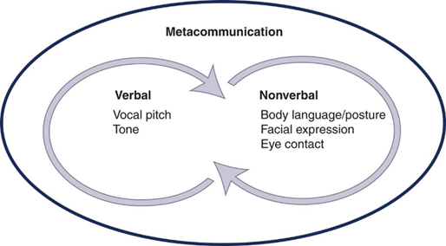

“Metacommunication is a broad term used to describe all of the factors that influence how messages are perceived. It provides information about how to interpret what is going on. Metacommunicated messages may be hidden within verbalizations or be conveyed as nonverbal communication, gestures and expressions” (Arnold and Boggs, pg. 95).
“Included with each verbal message are important nonverbal instructions (metacommunication) about how to interpret the message. If a nurse sits down in a relaxed position with full attention and good eye contact and actively listens, these verbal and nonverbal activities indicate interest and commitment. The same verbal message, delivered while looking at the clock or your watch, provides a nonverbal message that the person does not have your full attention” (Arnold and Boggs, pg. 95).


It is extremely important for effective communication that your nonverbal match your verbal messages. That they are CONGRUENT.
“Congruent Communication is a communication pattern in which the person sends the same message on both verbal and nonverbal levels… Congruent communication conveys both what the speaker is thinking and is feeling ” (NLPMentor.com, 2015)

Nonverbal behaviour should be congruent with the message and should reinforce it…
- Try to give nonverbal cues that are congruent with the message you are verbally communicating.
- When nonverbal cues are incongruent with the verbal information, messages are likely to be misinterpreted.
- When your verbal message is inconsistent with the nonverbal expression of the message, the nonverbal expression assumes prominence and is generally perceived as more trustworthy than the verbal content.
- You need to comment on any incongruence to better understand what is trying to be conveyed. For example, when you enter a room to ask Mr. Sala if he is having any postoperative pain, he may say “No,” but he grimaces and clutches his incision. After you comment on the incongruent message, he may then tell you that he is having some discomfort. Can you think of a clinical situation in which you changed the meaning of a verbal message by giving nonverbal cues that conveyed a message of “Don’t believe what I say.”? (Arnold and Boggs, pg 99).

Congruent communication
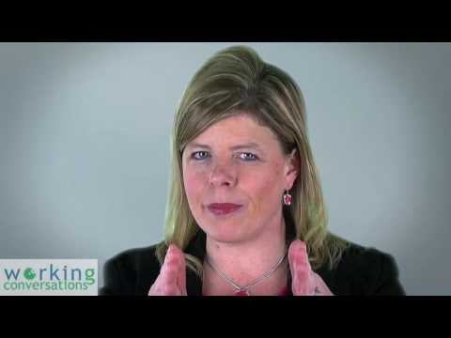

Professional and Social communication

By now you may be wondering why you are taking a communications course when you communicate every day. The answer is simple; up until now most of your conversations have been one of social construct, meaning, casual conversations with your friends and family called social communication. This course is designed to teach you about Professional communication to help you communicate effectively with clints and health care professionals.

What is Social Communication?

Social communication allows us to communicate with other humans both verbally and nonverbally. It is an unwritten set of rules taught by our peers and parents that changes over time and dependent on who/ what we are talking to. It allows us to express our wants and needs in a way that others understand, and to understand others wants and needs. It is a CASUAL conversation with no real right and wrong way to do it (American Speech Language Hearing Association, 2023).

Social conversations help us develop Social relationships that has mutual benefits directed by pleasure and self interest with others ( CNO. org, 2023).

What is Professional Communication?

“Professional communication is defined as a complex interactive process, used in clinical settings to help people achieve health-related goals (Street &amp; Mazor, 2017).

“Nurses communicate on many different levels… Although professional communication uses many of the same strategies as social communication, professional communication represents a specialized form of communication. It always has goals and a health-related purpose… Keep in mind that effective communication represents a combination of relationship building, information sharing, and decision making in communication, all of which are needed to achieve critically important clinical outcomes (Arnold and Boggs, pg. 71a).

“Professional conversations differ from social conversations. … Professional conversations have health-related expectations and legal and ethical boundaries about what can and cannot be shared with others (Arnold and Boggs, pg. 71a)..

Professional conversations help us develop Professional Relationships that are goal orientated.

Professional Communication should be effective and therapeutic. Both to be further discussed in upcoming modules.

- Effective communication is a two-way process - sending the right message, that is also being correctly received and understood by the other person/s.

  - Effective communication extends the concept to require that transmitted content is received and understood by someone in the way it was intended. The goals of effective communication include creating a common perception, changing behaviors and acquiring information.

- Therapeutic communication is a goal-directed form of communication used in health care to achieve objectives that promote the person’s health and well-being (Arnold and Boggs, pg. 559).

  - Therapeutic communication, … refers to a dynamic interactive process entered into by health care providers, with the person and significant others, for the purpose of achieving identified, health-related goals (Ruesch, 1961).
  - Therapeutic communication has purpose, active engagement of the person as a full partner in a health-related interactive process, and inclusion of relevant values and goals of the person and family emphasized throughout the dialogue. Additionally, the message takes into account the person’s and family’s values, beliefs, cultural contexts, developmental level, interest, and general health condition (Rosenberg &amp; Gallo-Silver, 2011).
  - Therapeutic communication occurs in a variety of ways: through words, facial expressions, body language, digitally, through documentation, and through behaviours.

Importance of Professional Communication?

“When health care professionals are not communicating effectively, patient safety is at risk … Lack of communication creates situations where medical errors can occur. These errors have the potential to cause severe injury or unexpected patient death. Medical errors, especially those caused by a failure to communicate, are a pervasive problem in today’s health care organizations… Communication failures as the leading root cause for medication errors, delays in treatment, and wrong-site surgeries, as well as the second most frequently cited root cause for operative and postoperative events and fatal falls” (O’Daniel M, Rosenstein AH, 2008).
“One study conducted in the late 1990s found that poor communication was responsible for causing between 44 000 and 98 000 patient deaths annually in American hospitals alone. Other studies found that poor communication was one of the leading causes of preventable deaths in hospitals” (Taran, 2011).

The greatest problem with communication is the illusion that
communication has even taken place.
George Bernard Shaw

References

American Speech Language Hearing Association. (2023). Social Communication. Retrieved from https://www.asha.org/public/speech/development/social-communication/

Boggs, C.M.O.Y.E.A. K. (2022). Arnold and Boggs's Interpersonal Relationships. Elsevier Health Sciences. Chapter 6 (US). https://pageburstls.elsevier.com/books/9780323763684

CNO.org. (2023). Professional versus Social Relationships. Retrieved from https://www.cno.org/en/learn-about-standards-guidelines/educational-tools/ask-practice/social-versus-professional-relationships/

O’Daniel M, Rosenstein AH. Professional Communication and Team Collaboration. In: Hughes RG, editor. Patient Safety and Quality: An Evidence-Based Handbook for Nurses. Retrieved from https://www.ncbi.nlm.nih.gov/books/NBK2637/

Taran S. An examination of the factors contributing to poor communication outside the physician-patient sphere. Mcgill J Med. 2011 Jun;13(1):86. Retrieved from: https://pubmed.ncbi.nlm.nih.gov/22363186/

Zain Books.com. Elements of communication and early communication models. Retrieved from http://www.zainbooks.com/books/mass-communication/introduction-to-mass-communication_4_elements-of-communication-and-early-communication-models.html

